Words in Hand Forth Valley Sensory Centre 11.11.24
Look at the activities. Choose one with your friends. Sign with Clark Denmark, Lilian Lawson, John Hay or Audrey Cameron. Find out the answers. You can take notes on paper or on an I-pad or on your phone. That will help you remember what they sign to you.


Activity 1: Technology
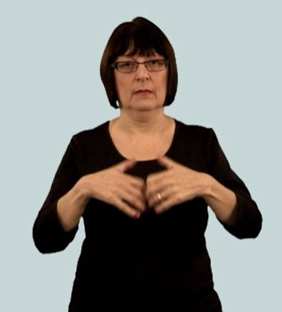 |  | 
In the 1980s, 40 years ago, deaf people used minicoms to type messages. They sent faxes. They wrote notes to communicate with hearing people. Some deaf clubs had large video recorders.
Today people in the deaf community use video for everyday communication, e.g. on FaceTime or WhatsApp.
In the 1980s deaf people met at the Deaf Club to chat. Today they meet anywhere because everyone can communicate quickly through smart phones. Fewer people go to the deaf club now. It is easy to arrange to meet people today so deaf people meet anywhere, e.g. cafes or pubs.
- Find out from Lilian, Clark, Audrey or John what they think. Have the changes in technology changed how the deaf community meets and interacts? Teachers: SOC 2-04a

Activity 2 Language
 | 
In the early 1980s some people realised that BSL was a real language. This was an important turning point. Before that, many deaf and hearing people thought sign language was ‘broken English’. Clark visited many deaf clubs around the UK explaining this idea in the 1980s. As a result, many deaf people became BSL teachers and got qualified to teach evening classes in BSL. Many hearing people learnt the language.
- Find out from Clark what his reasons were for going to the different deaf clubs.
Teachers: SOC 3-06a

Activity 3: Inequality
 |  | 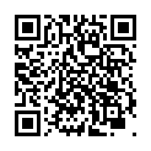

Inequality means that things were not fair. Life for deaf and hearing people was not equal.
- Ask Lilian, John, Audrey or Clark about the inequality they experienced in the 1980s as deaf people. Why was there inequality? What did the deaf community do about it to make things more equal for deaf people 40 years ago in the 1980s?
Teachers: SOC 4-04a

Back at home
Show your parents the activity you did. Explain to your parents or carers what you found out about life for deaf people 40 years ago. Why was the Edinburgh BSL project important?
Look at our Words In Hand website: Scottish Sensory Centre: Edinburgh BSL Research Project

Back at school
Can you make a video in BSL or write a newspaper story about what you found out? Remember to use sub-headings.

The 1980s: 1980 1981 1982 1983 1984 1985 1986 1987 1988 1989

