


University of Edinburgh
November 2022
A guide for assessing Cerebral Visual Impairment

A guide for assessing Cerebral Visual Impairment

Introduction
Cerebral Visual Impairment is an umbrella term for brain-related problems with vision. CVI is a complex condition, which requires assessment methods which ensure that apparent and subtle manifestations of CVI are uncovered and documented. To accomplish this, there is a need to investigate the potential outcomes of CVI within a variety of activities and tasks that provide data from different perspectives using multiple methods. This is important as despite CVI being first discovered in World war one there is only a small number of validated assessment tests to assess children with CVI and at this time there is no one assessment/system which evaluates all possible factors associated with CVI. This guide provides a synthesis of visual impairment assessments suitable for professionals to use when assessing children with Cerebral Visual Impairment.
How to use this guide
Due to the complexity of CVI, it can take time to assess children with CVI, one task per observation should be conducted to minimise fatigue. Children with CVI often have support from a wide range of professionals, a comprehensive assessment is beneficial with contributions from a multidisciplinary team including the family and where possible the child. The way in which children with CVI approach and complete various tasks (motor, cognitive, communicative behaviours) in different environments and respond to social cues can provide a useful insight into how a child’s CVI manifests. Observations can be completed independently from formal and/or informal assessments or can be an integral part of these methods. This guide provides a synthesis of the range of assessments available as well as suggested tasks that can be carried out with the child to assess and build a CVI profile for each child.

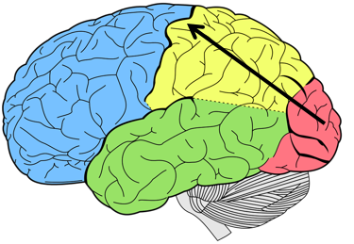

Dorsal Stream
What is the Dorsal Stream?
The Dorsal stream is a visual pathway between the occipital and posterior parietal lobes that maps the surroundings in an individuals environment and provides information to carry out visual guidance of movement. The Dorsal stream is sometimes known as the “where” pathway, it allows an individual to assess where things are in 3D space, like a ball being thrown or kicked across a park, an animal running towards an individual’s lap.

Damage to the Dorsal stream can cause:

- Motion deficits
- Difficulty with Spatial perception, orientation and navigation
- Impaired spatial guidance of motor activities (navigating crowds and obstacles, walking over steps, inaccuracy of reaching, grasping and pointing, saccadic and pursuit eye movements, estimating the speed of moving targets.
- Difficulty with surface pattern recognition, distinguishing between multiple objects at one time
- Difficulty with maintaining and shifting visual attention, intersensory attention (using more than one sense at one time), auditory search and processing.

Keywords linked to Dorsal Stream dysfunction:
Simultanagnosia, Simultanagnosia Vision, optic ataxia, Apraxia of Gaze, Dyskinetopsia, Parallel processing, Akinetopsia

Early Years

Area to assess  Early Years | Visual Assessment test | Example of Tasks you may wish to use to assess
Lower visual field Impairment or dysfunction | Using appropriate object size related to a child’s visual acuity | Present appropriately sized toys/objects on a table/tray top, close to the child’s body in a “peek-a-boo” game. Roll balls across the table or tray and watch for tracking.
Neglect of lower visual field | By observation | Place an object on the floor (e.g. a paper plate if it is within the child’s viewing capability) and between two adults. Ask the child to go to the other adult. Observe for moving around or over a paper plate.
Visual guidance of movement of lower limbs | By observation | Create a simple obstacle course and ask the child to step over a small hurdle, into a hoop then kick a ball towards a target (e.g. a bucket).
Visual guidance of movement of upper limbs and hands | Using a suitable size object based on visual acuity. Observing accuracy, speed and eye/hand alignment during the task. | During meal times, bring a spoon or cup in from different angles and encourage the child to reach for it. Place one item of food on a plate and offer it to the child. Look for over/under reaching as well as the correct size of grasp for the item to be picked up.
Floor boundaries | logMAR, Kay pictures | Once walking has been established, observe movement across thresholds and from carpet to lino, grass to concrete. Watch for over/under stepping.
Estimation of the speed of moving targets | CVIT 3-6 and by observation | Move a target across the midline at varying speeds and ask the child to touch it when it is in front of them. Roll a ball at varying speeds in front of the child and ask them to stop it when it rolls in front of them.
Visual search | By observation | Find familiar objects (spoon, cup, sock etc.) when presented on a plain background. Gradually increase the complexity of the background and number of items. Find a particular toy in a box.
Maintaining and shifting visual attention | Mirror test, Puppet Face, Neonatal Assessment Visual European Grid | Using two glove puppets, recite the nursery rhyme – Two Little Dickie Birds.
Intersensory attention | By observation | In a clutter-free, quiet environment, while the child is doing an activity that is within his or her threshold, introduce some background music, or have a conversation with another adult nearby. Repeat the activity in an environment that is quiet but where there is more clutter.
Auditory search and processing | By observation | While the child is not looking set a clockwork kitchen timer for a few minutes, and place it somewhere in the room. The child has to find it before the timer rings. Make sure the child is familiar with the ring of the timer first. Listen to some sounds from within the home and identify what they are. This video on YouTube can be used: https://www.youtube.com/watch?v=dZ1Rx3GDWBA
Area to assess | Visual Assessment test | Example of Tasks you may wish to use to assess
Lower visual field impairment or dysfunction | Using appropriate object size related to visual acuity | Take a walk with the child- observe their foot height. Roll a ball in from left or right and ask the child to kick it when it is in front of them.
Neglect of lower visual field | By observation | In a quiet sports hall or playground, ask the child to find different coloured footprints on the floor, step into and out of hula hoops, and step over canes between two skittles. Encourage them to move their head position often.
Visual guidance of movement of lower limbs | By observation | Play Simon says, observe the child navigating their way over sports equipment (i.e. a hula hoop or hurdles)
Visual guidance of movement of upper limbs and hands | Leahs mailbox | Using a suitable size object based on visual acuity. Observing accuracy, speed and eye/hand alignment during task. High Fives, reaching for one object on a plain surface, using one hand at a time. Observe for over or under reaching.
Floor boundaries | By observation | Outside – crossing from tarmac to grass. Look for over-stepping. Inside, changes of surface – carpet to lino.
Estimation of speed of moving targets | CVIT 3-6 and by observation | Rolling and bouncing a ball in a sports hall. Do initially in 1:1 setting then observe in a PE lesson.
Visual search | By observation | Circling the capital A, completing an inset jigsaw puzzle. Find coat/bag in the cloakroom. Using six familiar objects that the child can name, place them on the table and ask them to pick up a specific item.
Maintaining and shifting visual attention | Mirror test, Puppet Face, DTV-3 (ABCDEFV test) | Play musical statues. Given a choice of two familiar objects, ask the child “Which one would you like?”
Intersensory attention | By observation | Carry out a simple activity within the child’s threshold, in an area where there are distractions e.g. a corridor. Observe child’s behaviour for distractions.
Auditory search and processing | By observation | Can they navigate towards an auditory target? Can they use voice recognition to identify other individuals if they call their name?

Primary
Area to assess | Visual Assessment test | Example of Tasks you may wish to use to assess
Lower visual field impairment or dysfunction | Using appropriate object size related to visual acuity | Raising leg test, observe the child using a set of stairs- going up and down.
Neglect of lower visual field | By observation | Observation of moving around a familiar/less familiar environment including stairs.
Visual guidance of movement of lower limbs | By observation | Kicking a ball
Visual guidance of movement of upper limbs and hands | By observation | Using a suitable size object based on visual acuity. Observing accuracy, speed and eye/hand alignment during task.
Surface pattern recognition | logMAR, Kay pictures | Observation of crossing floor boundaries.
Estimation of speed of moving targets | By observation | Observe road crossings.
Visual search | By observation | Find items in the canteen e.g. cutlery, seat. A specific notice on a notice board.
Maintaining and shifting visual attention | By observation | Observe in class for shifting attention between Interactive White Board and own jotter/recording device. Observation in Science while carrying out an experiment.
Intersensory attention | By observation | In 1:1 setting, introduce various distractors e.g., music, conversations with a third person.
Auditory search and processing | By observation | Can they recognise friends/teachers by voice? Can they tell the direction of the approaching car by engine noise before it is seen?

Secondary

What is the Ventral Stream?
The Ventral stream also referred to as the “what” pathway is a visual pathway between the occipital and temporal lobes. The Ventral stream can be thought of as a visual library which aids recognition and memory, it allows individuals to recognise objects, patterns, textures and shapes.

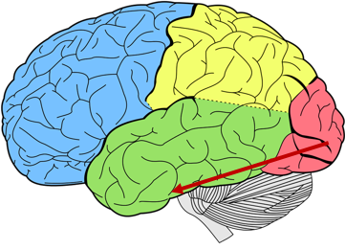
Damage to the Ventral Stream can cause:

- Impairments in contrast sensitivity and colour vision
- Difficulty recognising shapes and the orientation of lines (creating, copying, mentally rotating).
- Difficulty distinguishing objects, types of animals
- Difficulty recognising faces and/or perceiving facial expressions
- Difficulty with orientation in surrounding environments which are known (unable to use visual cues to guide travel routes due to having difficulty recognising objects).

It’s important to note that ventral stream dysfunction is not typically a stand-alone dysfunction, unlike dorsal stream dysfunction which can happen on its own. Ventral stream dysfunction typically occurs in conjunction with dorsal stream dysfunction.

Ventral Stream

Keywords linked to Ventral stream dysfunction:
Topographic agnosia, Prosopagnosia, Object Agnosia, Shape Agnosia, Ventral stream dysfunction, contrast sensitivity, Lower visual field impairment

Area to assess  All Stages | Visual Assessment test | Task
Identification of people | Through observation | Asking the individual to pick out classmates in person. Also, use the school staff photograph display and ask the child to find their teacher etc.
Identification of Objects | Lea mailbox (for children over the developmental age of 4 years) | Presenting familiar objects to the individual and asking them to tell you the name. Ask the individual to find different objects in the classroom
Identification of Shapes | Lea Puzzle test or Lea rectangles (for children over developmental age 6 years) | Selecting a shape in 2d or 3d
Identification of Words | Through observation | Present a single word at a time
Identification of facial expressions | Through observation | Asking the individual to make different facial expressions. Make different facial expressions and ask the individual to tell you how you are feeling.
Orientation in the surrounding environment | Through observation | Observe the individual walking in a safe environment
Orientation of lines: Creating, copying, mentally rotating | Beery & GMDS-ER (for children 0-8 years) | Copying a drawing (see Appendix 4), copying coloured patterns using coloured cubes/lego  https://www.pearsonclinical.com.au/filemanager/uploads/Visual%20Motor%20Integration%20Webinar.pdf

Appendices

Appendix 1: Recording table
Name of Pupil:
Name of Assessor:

Date and time of Assessment | Name of Assessment used (e.g. test name or observation used) | Comments on Environment/Surroundings | Findings
Area to assess | Description | Things to consider
Lower visual field impairment or dysfunction | When an individual has a loss of the lower visual field. | The child’s head position, look out to see if the child prefers lying down on their stomach. If the child trips over things, misses the bottom of the television screen.
Neglect of lower visual field | When an individual has a disorder of attention in which an individual exhibits a lack of response to their lower visual field. | If the child were to move their head position from left to right to scan below are they able to use this method to search for objects in their lower visual field.
Visual guidance of movement of lower limbs | The ability to combine visual mapping of the environment and use the lower limbs. | The individual use of their lower limbs
Visual guidance of movement of upper limbs and hands | The ability to combine visual mapping of the environment and use the upper limbs to grasp/ reach out for objects | The child’s accuracy of reach, the child’s hand grasp
Surface pattern recognition | The ability to distinguish between multiple objects at one time (crowding). | The complexity of the background
Estimation of the speed of moving targets | The ability to process movement | Whether the individual can process slow, fast or still objects in the environment. For example, the speed of a person moving towards them, a train passing the platform.
Visual search | A goal-oriented activity that involves an individual actively scanning the environment to locate a target/object among irrelevant non-targets/objects. | Whether the child organises objects in a specific way to identify objects. The familiarity of the surroundings to the child.
Maintaining and shifting visual attention | The ability to process a vast amount of information at one time and prioritise/share attention by focussing on more than one stimulus or process at one time. | Consider the duration and the child’s behaviours
Intersensory attention | The ability to attend to a specific sensory modality whilst disregarding information from other sensory modalities. | Consider the noise in the environment
Auditory search and processing | The action of being able to process and attend to auditory modalities in the environment. | If there is noise in the environment, can the child filter through this
Appendix 2: Dorsal stream descriptions
Appendix 3: Ventral stream descriptions

Area to assess | Description | Things to consider
Identification of people | Ability to identify people using their vision alone. | The familiarity of the person, the distance of the person, and whether the person introduces themselves to the child.
Identification of Objects | Ability to identify and name objects | The positioning of the object, the colour of the objects, and whether the objects make a noise or light up.
Identification of Shapes | Ability to identify and name shapes. | Whether the shape is provided in a 2D or 3D format.
Identification of Words | The ability to identify words/letters | Consider the child’s developmental level and present words in a format that matches the child’s visual acuities. Present one word/letter at a time.
Identification of facial expressions | The ability to identify, attend to, imitate or name facial expressions | Consider if the child can identify facial expressions on an individual’s face or through the use of cartoon cards. Converse with the child to see if they have an understanding of what the expression means in their own words.
Orientation in the surrounding environment | For the individual to make use of visual cues in the environment to navigate in familiar and known environments. | Consider the familiarity of the environment
Orientation of lines: Creating, copying, mentally rotating | The ability of the individual to draw from instruction/memory or copy a drawing. | Consider the child’s dexterity. Consider leaving a pause between explaining the task and allowing them adequate time to perform the task.

Appendix 4: CVI term definitions
Term | Meaning
Simultanagnosia | Difficulty in putting together and seeing the whole image simultaneously. Individuals with Simultanagnosia can have reduced visual attention
Optic Ataxia | Difficulty judging distance and depth to guide movement
Apraxia of Gaze | A diagnosed condition when an individual is unable to consistently look at targets when asked.
Dyskinetopsia | Impairment in how movement is seen. Individuals with Dyskinetopsia can also find sounds such as words too fast to hear. The optimal speed needs to be established for every child, the severity can vary.
Parallel Processing | An individuals ability to process multiple stimuli at one time.
Akinetopsia | Akinetopsia is where movement is not seen at all.
Topographic Agnosia | The inability or difficulty of remembering routes, even when they might be familiar.
Prosopagnosia | The inability to recognise faces also known as “face blindness”.
Object Agnosia | Difficulty recognising objects visually
Shape Agnosia | Difficulty recognising shapes visually
Contrast sensitivity | The ability to perceive sharp and clear and distinguish between finer increments of light versus dark

Appendix 5: Raising leg test instructions

Ensure the individual is in a safe environment and provide them with the following instructions, ensuring to count to eight before reading the next step.
- Ask the child to take to a standing position.
- Ask the individual to take a deep breath for the count of five and after five to breathe out. This will help the individual to adopt an upright position.
- Ask the individual to point fully and extend their arms facing forwards whilst maintaining a straight position and standing tall.
- Next, ask the individual to move their arms from the centre and move both arms to the side of their body aligning with the shoulders.
- Once the individual has their arms pointing outwards (like an aeroplane position) instruct them that they will be asked to lift one foot slowly without bowing their head- they should look straight ahead. Individuals must keep their heads raised/positioned up high. Ask the individual to slowly lift their foot until they can see their foot (without looking downwards).

Note: There is no calculated measurement for this test. Instead, the observer should look at the point where the individual can see their foot visibly whilst the individual continues to look straight ahead. The individual's foot should roughly be the same as the high point of their elevated foot when they are walking. If it is higher, this can suggest that the individuals may have a lower visual field impairment.

A lower visual field impairment can vary for many:
- It may depend on how high the individual is- for some individuals the whole of the bottom half of their lower visual field is affected and for others, it can be the bottom slither.
- Another point to be aware of is how living with a lower visual field impairment can affect the individual- for some it can mean they have a complete absence of vision (neglect) and for others, it can mean that they see less clearly and as a result, their visual acuity is worse.

Appendix 6: Copying the shape task
Purpose: To examine visually guided hand movement (motor control), and the ability to accurately copy a novel figure presented as a line drawing. To be able to copy a pattern/drawing the child processes the drawing in a series of fragments. Each fragment must be seen and stored in the child’s visual working memory before being transferred to the hand with the necessary output spatial coordinates.

Instructions: Ask the child to copy/draw the shape, and ensure to provide the child with time to do this task. Fold over the dotted line to ensure that the child is only asked to copy one shape at a time.

Results: If the child copies the shape with misplaced fragments or faulty coordinates this can be a sign of optic ataxia. If fragmentation and misorientation are apparent the child should be referred to complete a Beery assessment to identify issues with visual search and optic ataxia.

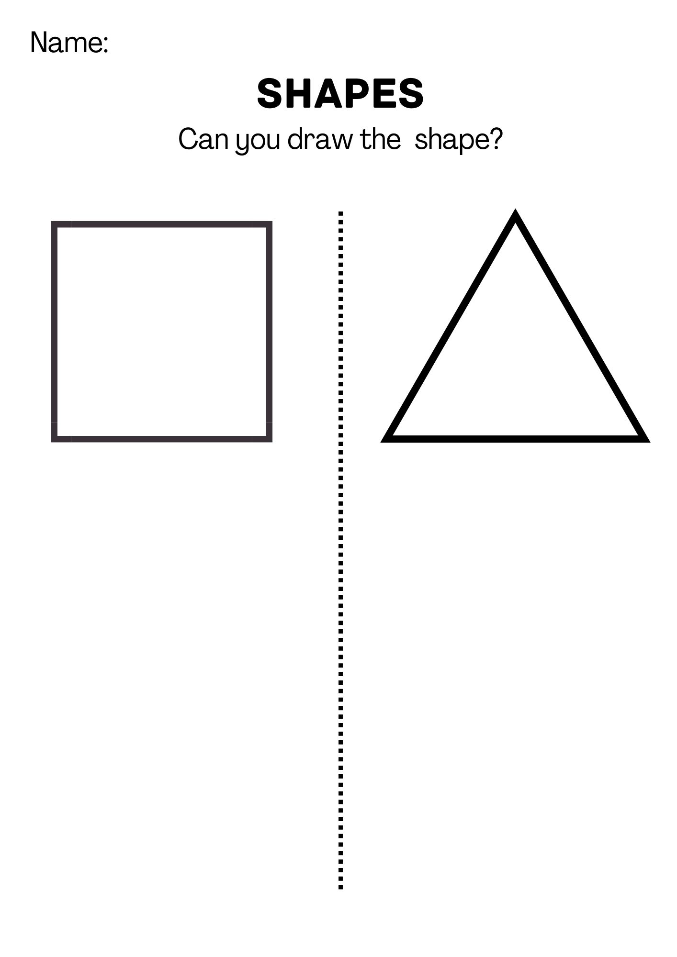

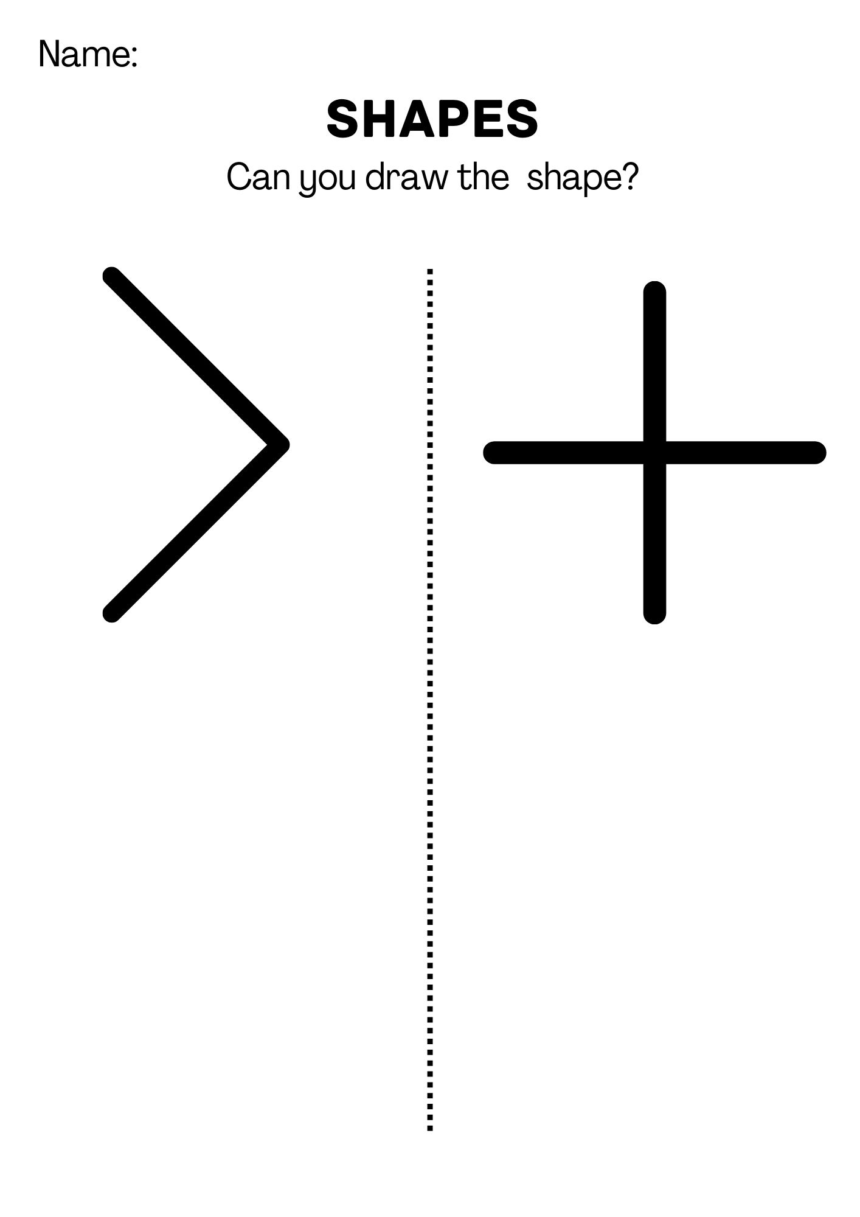

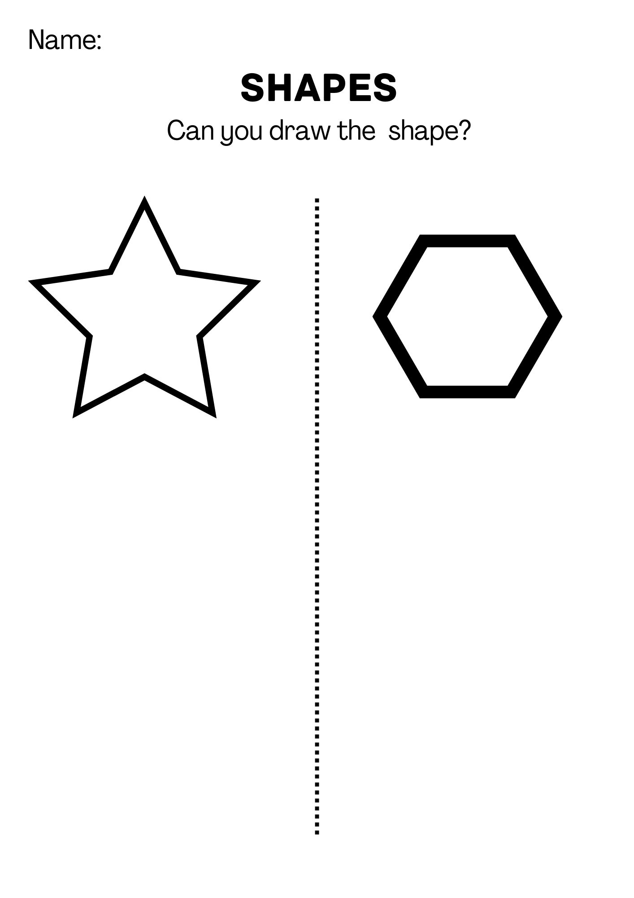

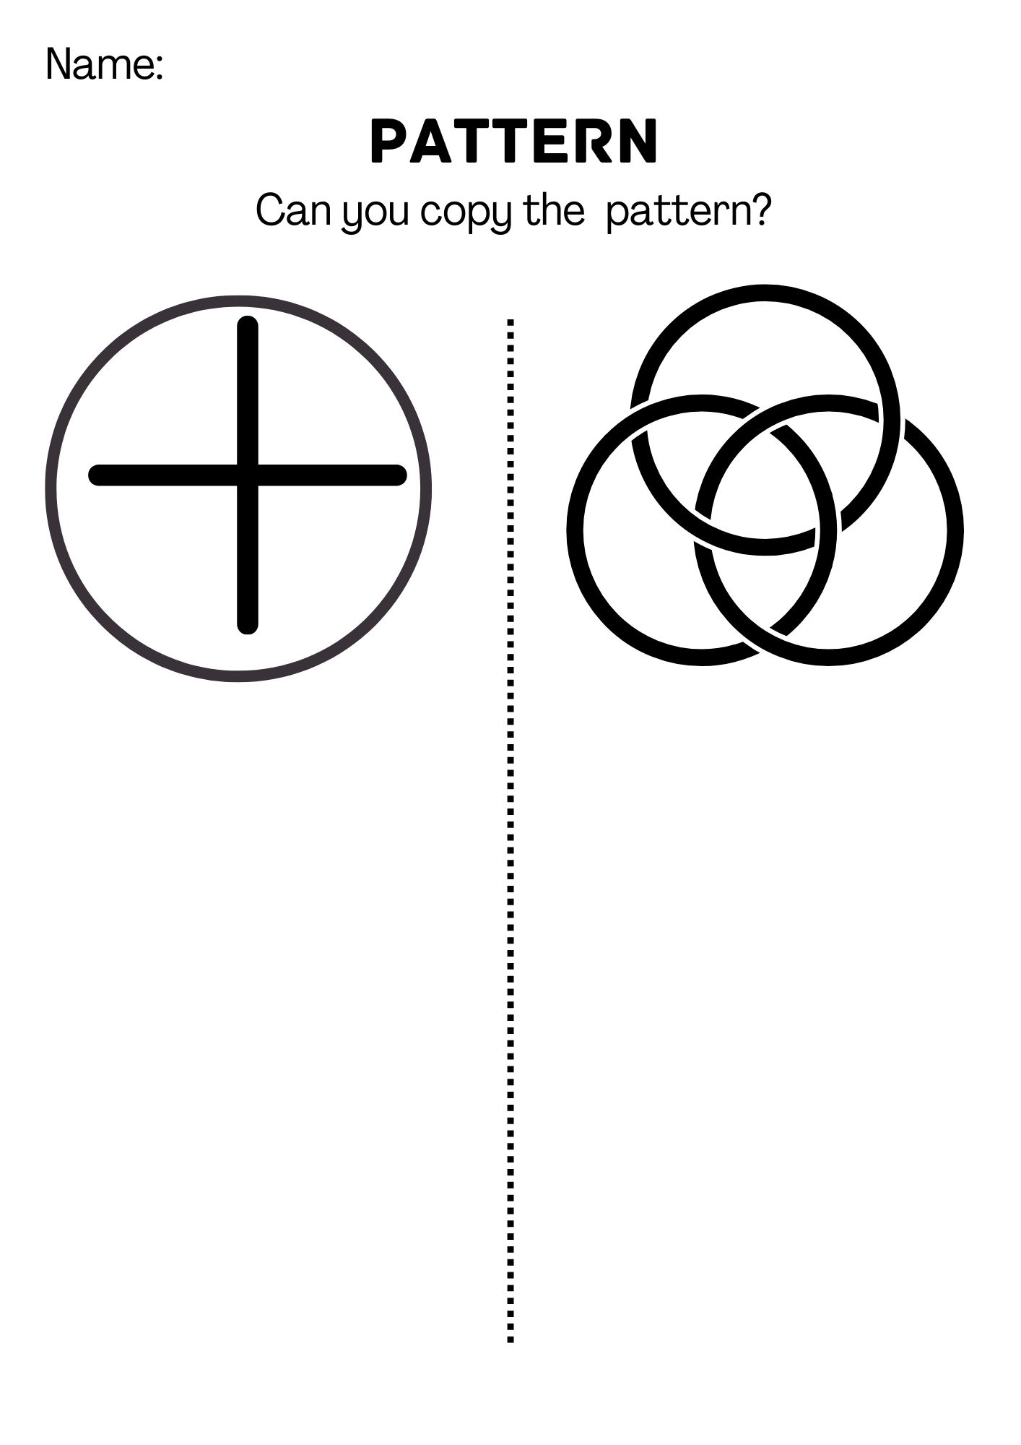

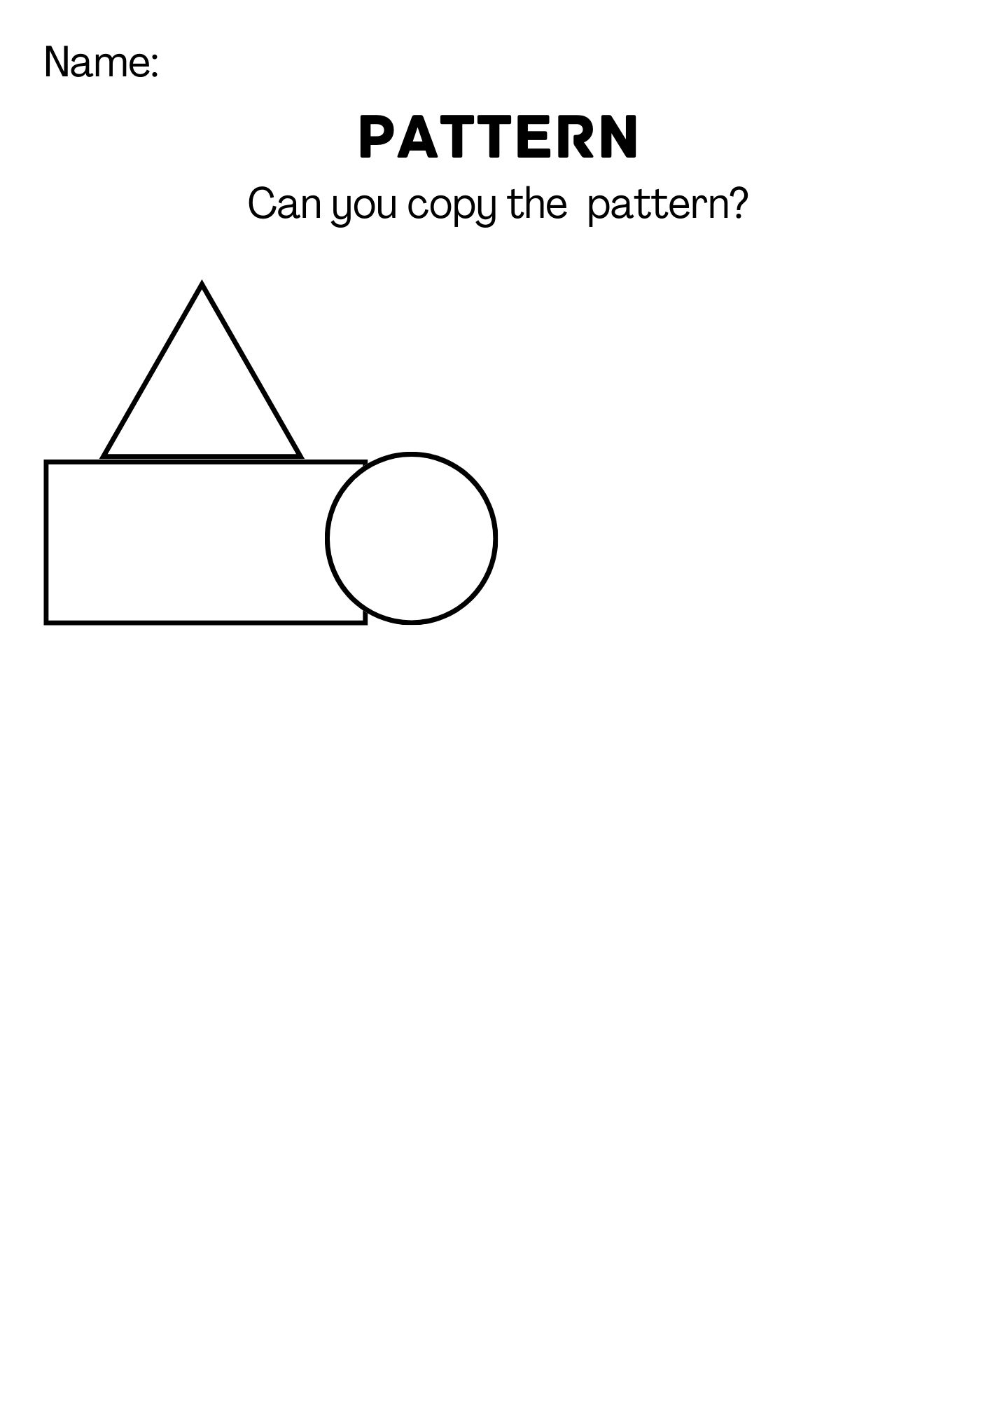

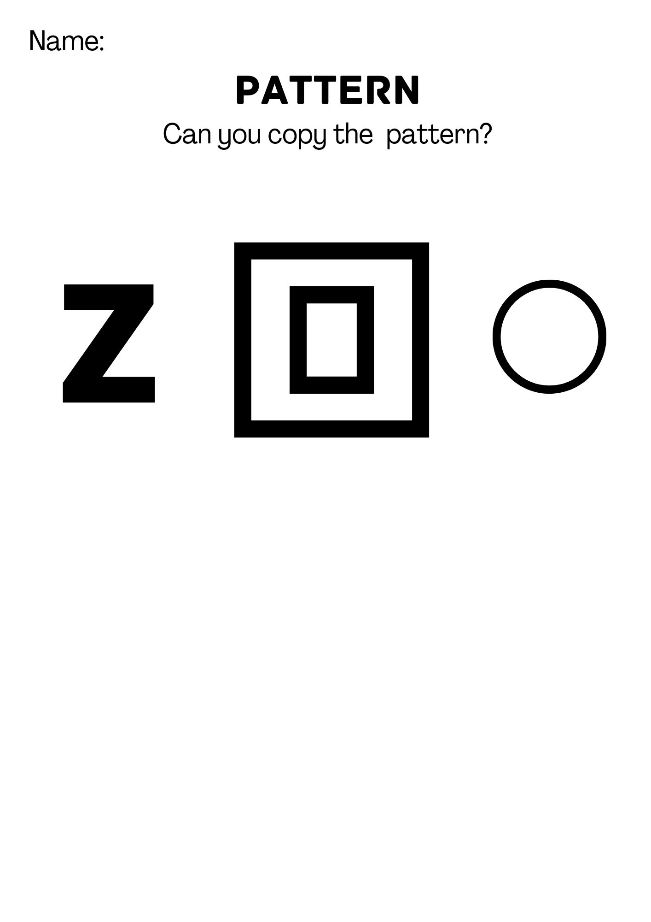

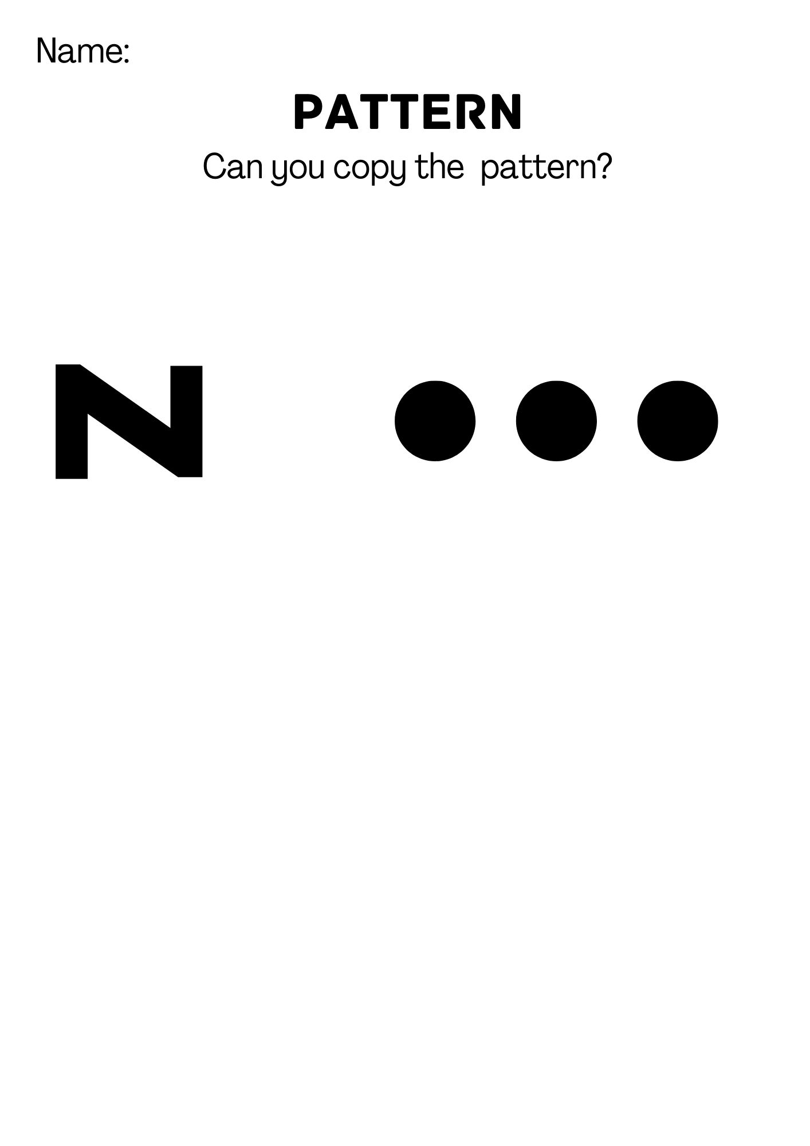

Appendix 7: Lego/block pattern
Block pattern- used for a child with the developmental age of 19-36 months and above.
Purpose: a test of spatial cognition involving visually guided construction for children. This task requires the child to recognise the global form of the construction, visuospatial manipulation to determine how this global form can be made out of the component blocks, and the ability to plan and execute a sequence of visually guided actions to achieve this. Thus it has elements of both ventral and dorsal stream visual function. Some of the construction will require relatively good fine motor control to balance blocks on each other accurately. Stiles & Nass (1991) found that children with right-hemisphere brain damage have specific deficits in this task.
Materials: Two sets of 8 wooden rectangular blocks (6x 2.75cm x 1.5cm) of the same bright colour (one set for the tester and one for the child). A cardboard screen is used to hide the child’s view of the tester constructing the design which is about to be copied.
Procedure: If the parent is present, ask the parent/carer to refrain from assisting the child in any way except for verbal encouragement. It can be helpful to record the process of construction with a video recording device- if a video recording device is used, it should be positioned at least 2 meters from the child, on the far side of the table to minimise distraction. Children are tested for their ability and accuracy in copying three or more model constructions made by the tester. During the test, before each construction, the tester places the exact number of blacks required for construction in front of the child. The screen is placed behind the child and the tester. The tester constructs the design out of view of the child, then removes the screen and asks the child to make a construction “just like this one”. Give the child three minutes to copy the construction or until the child gives up, whichever comes first.
Results: The table below gives the scoring scheme, with 0-2 points for each construction. A score of 2 represents a near-perfect copy; a score of either 0.5 or 1 or better, depending on the test, is taken as a “pass” for each particular construction. The table also indicates the constructions which age each age group can be expected to pass on this criterion; if a child consistently fails to achieve the pass for their age group it would indicate a possible delay in visuo-spatial cognition. It should be apparent if clumsy motor control is the major factor preventing successful construction.

Scoring System
This scoring scheme is modified from the scoring scheme of Stiles & Nass (1991). In each case a score of 2 represents a near-perfect construction, whilst scores of 1 or 0.5 show that the child has grasped some basic principles of the construction despite imperfections in its execution.
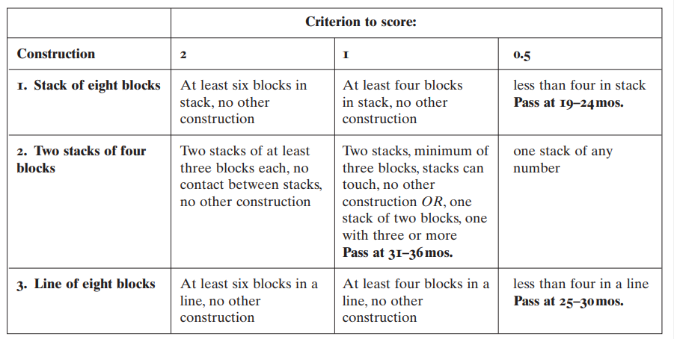
Table 1: Scoring scheme for the child’s copies of block constructions

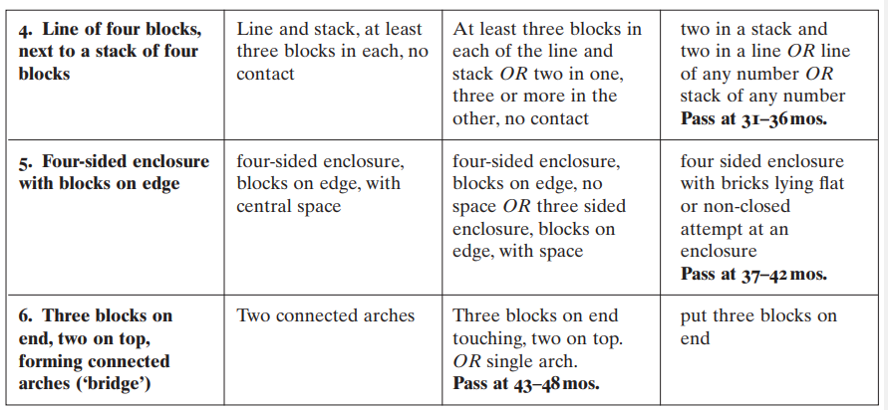

Note: This test can be adapted for younger (13-18 months) children by encouraging them to carry out free play If the child stacks two or more bricks this is scored as a pass (exact alignment of one brick on top of another is not required for a pass). The observer can carry out a similar task using lego bricks as follows:
Instructions and Scoring system from Atkinson, J., Anker, S., Rae, S., Hughes, C., & Braddick, O. (2002). A test battery of child development for examining functional vision (ABCDEFV). Strabismus, 10(4), 245-269.

Appendix 8: Copying the coloured cubes/Lego pattern examples
(The below patterns can be altered- it’s important to start off with a simple pattern).
Appendix 9: ABCDEFV – The embedded figures test
Purpose: The embedded figures test challenges the child's ability to give attention to and recognise individual shapes /objects despite attentional competition from surrounding/overlapping items. This appendix is to provide an example of the DTVP-3.This test should only be carried out by a trained professional.
Materials: There are two cards card A contains an overlapping outline drawing of animals and card B contains shaded cat shapes in a shaded tree.
Procedure: The child is asked to point out which animals are on each card. Record the number of items reported by the child in each picture. If the child is reluctant to play and spontaneously find or name the animals, ask the child to find a particular animal by name. If the child points to animals but gives the wrong names, score as a pass on these items. If on Card B, the child points to all the shaded areas in the tree rather than to the cats specifically, score this as a fail.
Results: A child of 25-30 months would be expected to detect 3/5 animals and 2/4 cats. Beyond the age of 30 months, the pass criteria increase to 5/5 animals and 3/4 cats. Failure on this task may represent a general delay in development, a specific learning difficulty or in the case of CVI – simultanagnosia.
Note: Further objective evidence for simultanagnosia has to be looked for in a test called the Beery VMI.
Picture A
Picture B
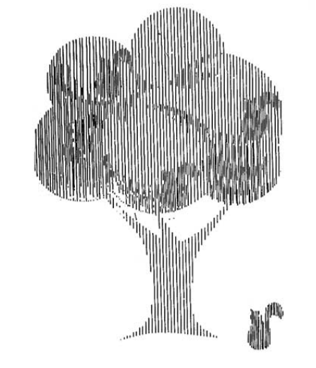
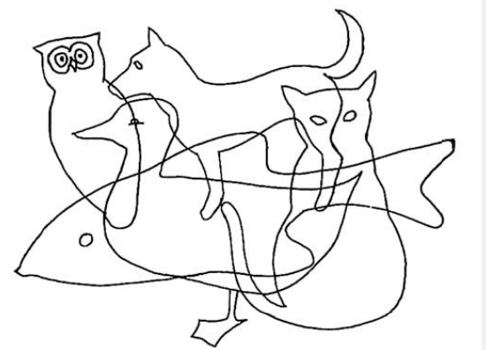

Reference: Picture A & B - Frostig, M., Miller, A. M., & Horne, D. (1966). The developmental program in visual perception: beginning pictures and patterns (Vol. 1). Follett Publishing Company.

Appendix 10: A note before assessing a child’s CVI
Before you assess a child with CVI there are a few things to bear in mind:
- You will need to allow adequate time for the child to process any visual information you provide and to make a response.
- You need to be aware of visual fatigue and the child’s mood- is there a time which suits the child best? Assessing a child on a Wednesday morning compared to a Friday afternoon could yield different results. It’s important to remember that an assessment/observation is just one snap shot in time, children with CVI’s visual abilities can be variable.
- It’s important to assess the child in a calm, quite environment avoiding visual and auditory overload. Children with CVI often prefer routine and there vision can be variable when they are in an unfamiliar environment.
- It is helpful to obtain information from school staff, parents and carers about the child’s visual behaviours, their interests and activities and what engages their attention.
- Position and support is important to consider- some children may put all their effort into posture and head control and can mean they are unable to attend to visual tasks. With help from Occupational therapists or physio therapists it can be helpful to support these children to be more visually responsive. For example a child may find lying on the floor or over a wedge easier rather than sitting up in a chair. It is also important to know about the child’s movement abilities including their ability to use their hands to reach out as well as their mobility.
- It is also important to be mindful of the child’s developmental level and to not expect them to develop visual skills which are in advance of their developmental and cognitive abilities.
As well as the information provided in this guide it is also important to observe the child’s response to light, visual awareness of familiar and unfamiliar objects, eye movements, ability to recognise objects in pictures, visual response to people, eye movements, visual acuity and contrast sensitivity.
When considering the child’s ability to recognise objects, pictures and then symbols it is important to know that typically developing sighted children can:
- Name objects from the age of 18 months
- Name pictures from 21 months
- Name pictograms from 33 months
- Name letters from 42 months

Appendix 11: CVI Vision Report
Name of Pupil:
D.O.B:
Name of Professional supporting the child:
Childs likes/dislikes and interests:
Include likes/dislikes and interests of the child- do they have a favourite toy, television shows, books. Do they dislike loud noises, do they prefer following a routine?
Notes on medical history:
Include notes on the child’s medical history if known- for example- if they have been diagnosed with CVI, if they are supported by different professionals if known – for example speech and language, Physio therapists etc.
Notes on vision behaviour and vision:
What can the child see? – What is the child’s visual acuity, contrast measurements, at what distance
Does the child have a preference of position- does the child have a preference for still or moving objects?
What is the child’s preference of lighting conditions?
What size of object can the child see, include other characteristics of object? - It is good practice to include a photo of the objects used- this will help other professionals to see the object used and can improve results.

References
Atkinson, J., Anker, S., Rae, S., Hughes, C., & Braddick, O. (2002). A test battery of child development for examining functional vision (ABCDEFV). Strabismus, 10(4), 245-269.

Frostig, M., Miller, A. M., & Horne, D. (1966). The developmental program in visual perception: beginning pictures and patterns (Vol. 1). Follett Publishing Company.

Stiles, J., & Nass, R. (1991). Spatial grouping activity in young children with congenital right or left hemisphere brain injury. Brain and Cognition, 15(2), 201-222.

Links to visual assessment tests
Logmar - https://www.sussex-vision.co.uk/distance-tests/logmar-charts
Kay pictures - https://kaypictures.co.uk/product-category/vision-tests/
Cvit 3-6 - https://kathleenvancleef.org/cvit-3-6/
Puppet face- http://www.beesneez.co.uk/
Beery- https://www.pearsonassessments.com/store/usassessments/en/Store/Professional-Assessments/Academic-Learning/Brief/Beery-Buktenica-Developmental-Test-of-Visual-Motor-Integration-%7C-Sixth-Edition/p/100000663.html
Leahs mailbox- http://www.lea-test.fi/index.html?start=en/vistests/instruct/pvmailbo/pvmailbo.html
The ABCDEFV test is available in DTVP-3- https://www.pearsonclinical.co.uk/store/ukassessments/en/Store/Professional-Assessments/Motor-Sensory/Brief/Developmental-Test-of-Visual-Perception-%7C-Third-Edition/p/P100009107.html

