How to Download Images from APH Tactile Image Library
- Select you image and click on download.
- Go to your Downloads folder and you will find the image. It will be downloaded as a PDF file.
- RIGHT click on the file name, then select “Open With” and then choose Word.
- A pop up box will appear, click OK.
- Your document will open in word but will be locked for editing. Click on Enable Editing.
- A pop up window will appear, click OK.
- Click on the “Layout” menu in the ribbon.
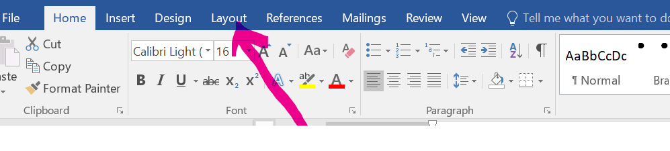
- Then on size.

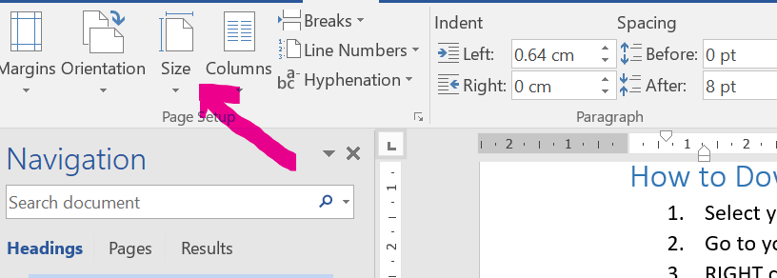
- Choose A4.
- Save your Word Document before making any further changes.

