How to Create a Foreign Language Style Template in Word

1. Open the Styles table by click on the arrow as shown below:
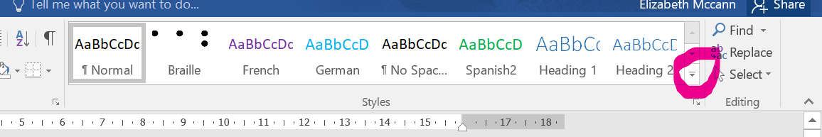

You will now see this:

2. Click on Create a Style. 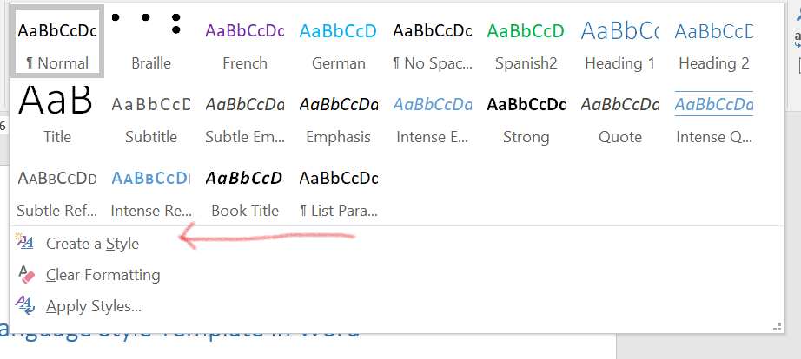
3. Give your style a name – usually the name of the language.

4. Now click on Modify (NOT the OK buttom).
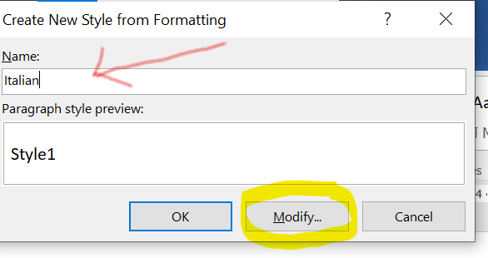

5. You will now see the screenshot below.
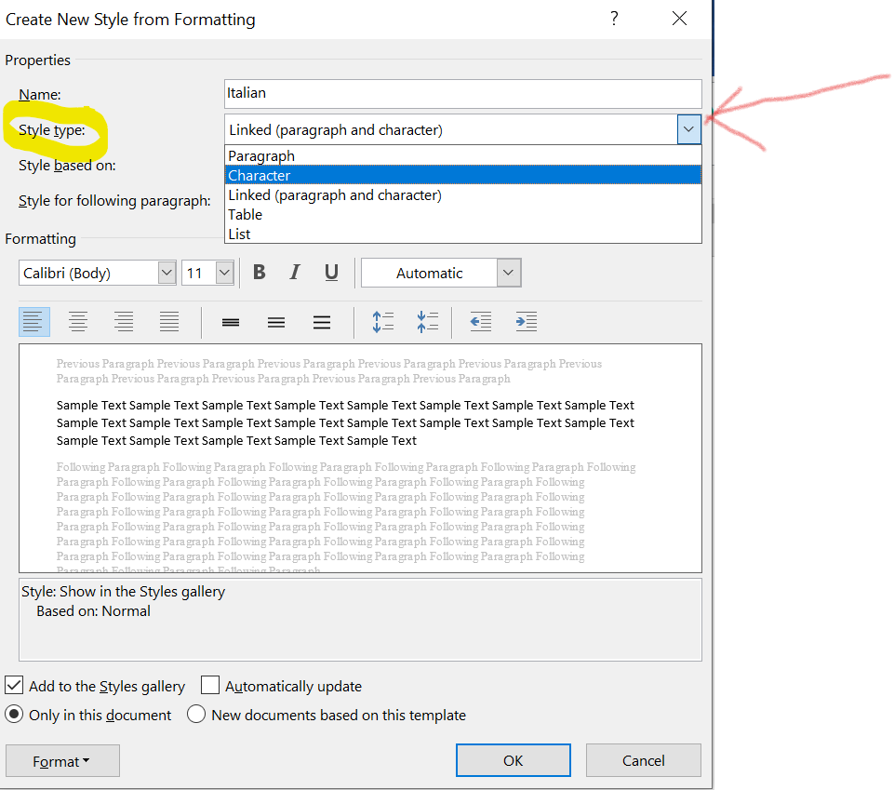
6. Look for Style Type (circled in yellow) and click the down arrow to the right (shown by the red arrow).
7. Select “Character”.
8. Make sure the Formatting: font and size are set to the default for your computer. If it is blank use the drop down arrows to change it as shown here:
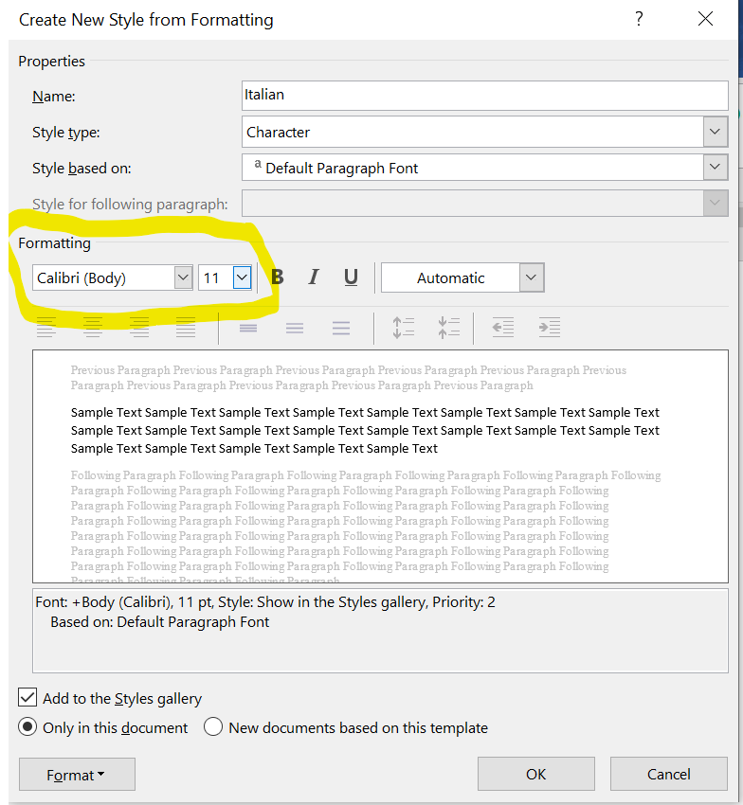

9. Select a colour in which you want your foreign language to appear. This makes it easier when marking up. Do this by going to the box circled in pink, press the down arrow and change the colour.
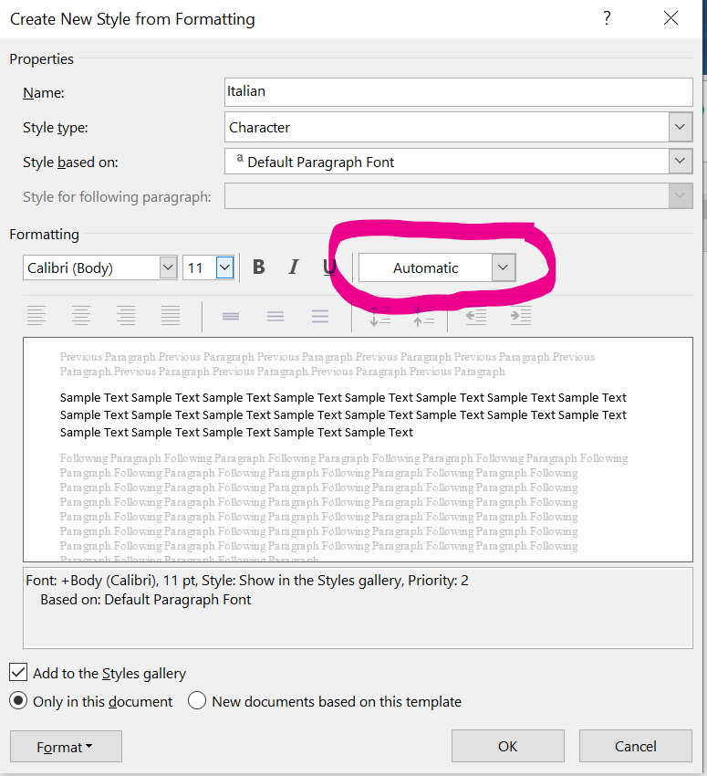

10. Now go to the format button in the bottom left of the screen and click the down arrow.
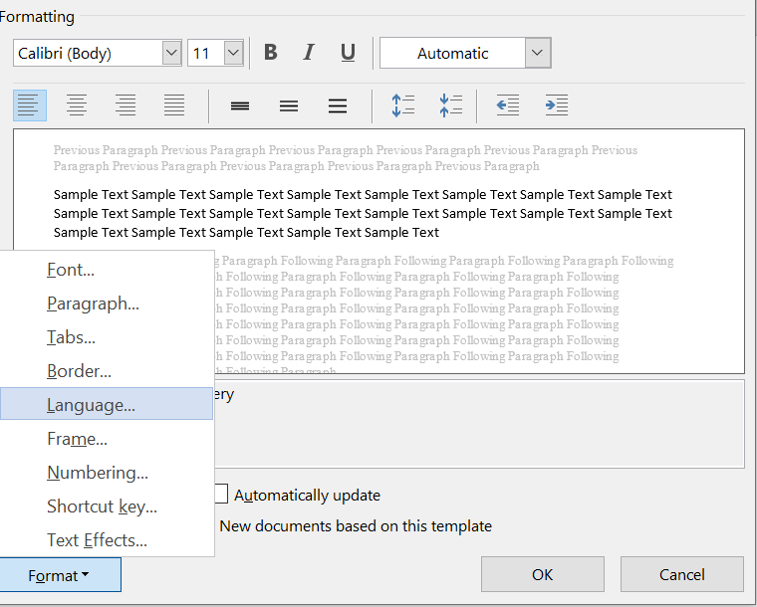
11. Click on “Language” as shown above.
12. You will need to scroll to find the language that you need. Make sure you choose French (France) and German (Germany) as shown below.
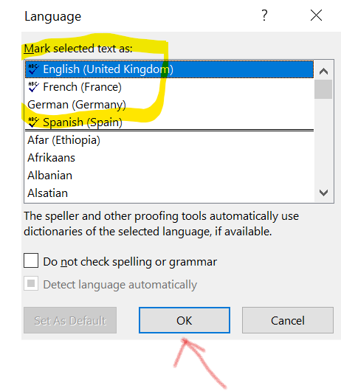
13. Click on OK once you have selected the language. This will take you back to the first page.
14. Now towards the bottom of your screen, click the button, “New documents based on this template” as shown in yellow.
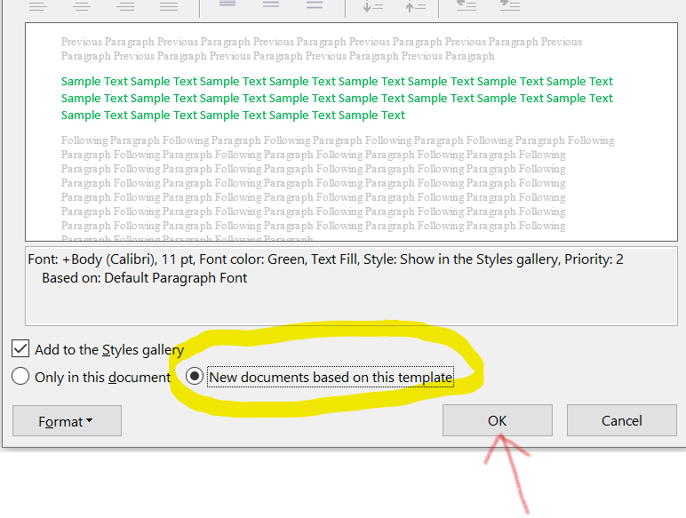
15. Click on OK at the bottom and that’s it!

