Hearing aid checks
- Remove aids from ears.
- Check for wax and condensation.
- Remove wax using pick and wipes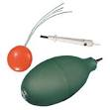 (Pick – grey with brush – use hook end to remove wax.
- Detach tubing and mould and use puffer to remove condensation. (Green in picture)
- Re-attach tubing to hearing aid – ensure correct mould with correct hearing aid – small coloured dots on bottom of aid – red for right and blue for left. If audio shoes and receivers 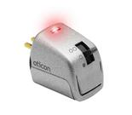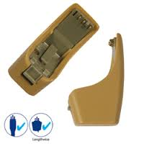 are attached to hearing aids they will need to be removed to check dots.
- To check if hearing aid is working close hearing aid battery compartment and hold in hand for a few seconds. If it is working it will beep and make noise. If not it won’t make any noise at all.
- Listen for distortion through stetoclips.
- To change battery see change battery instructions – take orange sticker off battery and leave for a few seconds before putting into hearing aid as they are air-activated. Check it is working as before.

