Cochlear Implants and Assistive Listening Device
- Receivers to be attached to processor at the start of the day, after break and after lunch and removed when going outside.
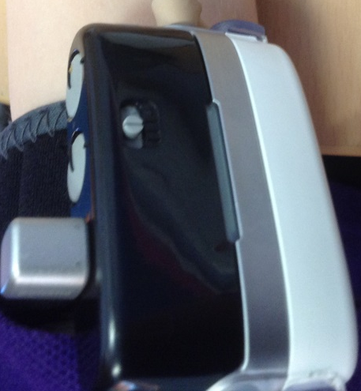
- Small circle (at Programme 1 in diagram) should be moved to programme 2 with the line in the circle matching up.
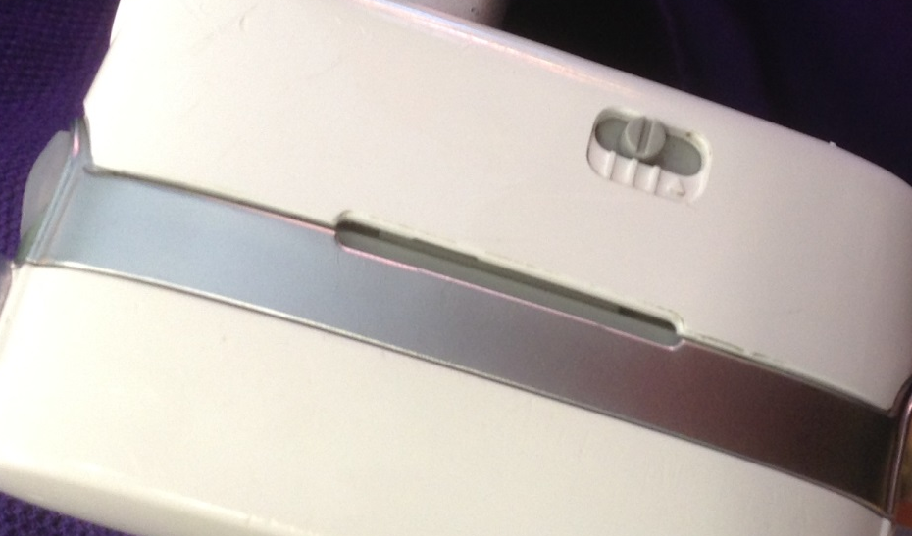
- This can move throughout the day when attaching the receiver. Check it is on the correct setting.

- Check that, when you are talking near the pupil, the disk is displaying a green flashing light.

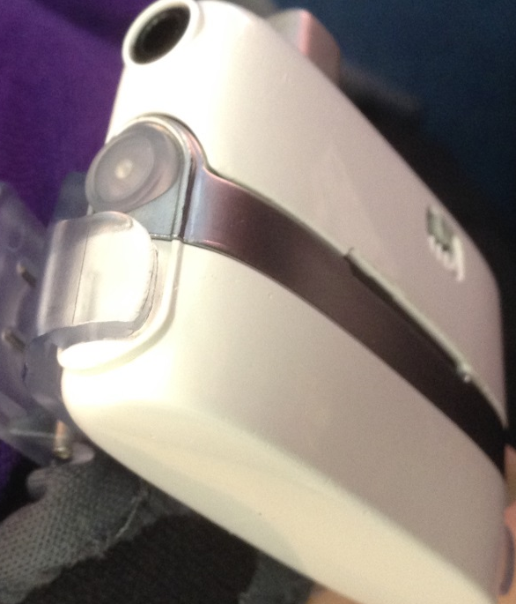
- If displaying no light at all press and release the disk, being careful not to turn off the processors with the button at the bottom.
- If displaying a red light the battery needs replaced. It may display a red light before turning green. The battery needs replaced if the red light continues.

- If pupil cannot hear properly they may begin to shout. If this happens check the disk on the processors for the green light.
Whole part – Processor.
