Oticon Amigo T30
The personal FM system consists of a transmitter microphone used by the speaker (such as the teacher in the classroom, or the speaker at a lecture) and a receiver used by the listener. The receiver transmits the sound directly to the hearing aid. For this to work the pupil must have their receivers on their hearing aids switched to the on position. As the FM system provides a direct feed into the hearing aid it will be easier for the pupil to hear you when you are talking to the class. To check it is working you could turn away from the class and speak into it. The microphone should be worn like this 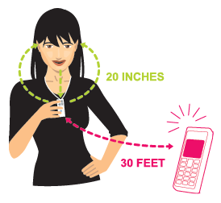on the lapel. The transmitter 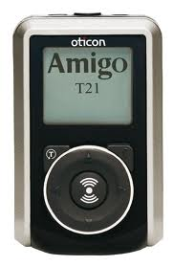 can be clipped onto trousers or a belt or placed carefully in a pocket, with the microphone attached to the lapel area.

The receivers 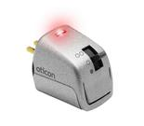 are attached to hearing aids on the bottom of audio shoes 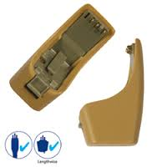. These should be removed every day before the pupil goes home from school. It would also be advisable to remove them at snack time, lunch time and during P.E. 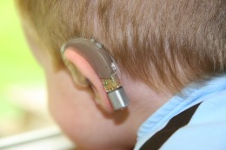

On the receiver there is a 3 position mode switch - a black circle at the bottom which means the receiver is off, one clear dot and two clear dots. The red light on the receivers will show that the receiver is working and picking up a signal from the transmitter.
The transmitter is switched on using the button at the top – there will be a steady red light to show this is on. Turn on the transmitter during whole class/group direct teaching when you want the hearing-impaired pupil to hear what you are saying. When working with other children or not addressing the hearing-impaired pupil press the top button to mute the microphone – this will then show a flashing red light.
Turn off the processor when away from the classroom e.g staff room, toilet etc. The transmitter needs charged each night – similar to a mobile phone. The transmitters have rechargeable batteries but they can take disposable ones if required.
Remember not to charge them with disposable batteries in them as this can damage the equipment.

